Lab 1: Distributed Lag Model
Write a C program to find the growth in national consumption for five years using Distributed Lag Model given below:
I = 2 + 0.1 $Y_{-1}$
Y = 45.45 + 2.27 (I + G)
T = 0.2 Y
C = 20 + 0.7 (Y – T)
Assume the initial value of $Y_{-1}$ is 80 and take the governmental expenditure in 5 years to be as follows:
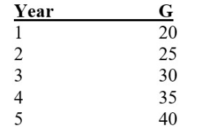

Source Code:
#include<stdio.h>

int main(){
float Y0=80.0;
float I, Y, T, C;
int govexp, year, G[10];
printf("Enter the number of years: ");
scanf("%d", &year);
printf("Enter the goverment expenditure: \n");
for(int i=0; i<year; i++){
printf("Enter the government expenditure of year %d: " ,i+1);
scanf("%d", &G[i]);
}
printf("Year\tG\tY\tI\tT\tC\tGrowth in Consumption\n");
for (int j = 0; j < year; j++) {
I = 2 + 0.1 * Y0;
Y = 45.45 + 2.27 * (I + G[j]);
T = 0.2 * Y;
C = 20 + 0.7 * (Y - T);
float growth = C - (20 + 0.7 * (Y0 - 0.2 * Y0));
printf("%d \t%d \t%.2f\t %.2f\t%.2f\t%.2f\t%.2f\n", j + 1, G[j], Y, I, T,
C, growth);
Y0 = Y;
}
return 0;
}

Output:
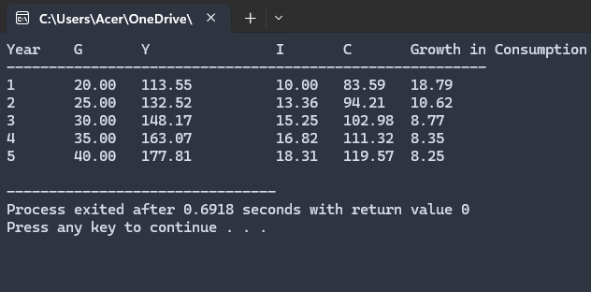

Lab 2:
In a single pump service station, vehicles arrive for fueling with an average of 5 minutes between arrivals. If an hour is taken as unit of time, cars arrive according to Poison’s process with an average of λ= 12 cars/hr. Write a C program to generate Poisson distribution for x = 0,1,2, …. 15.
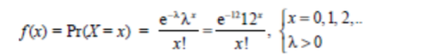
Source code:
#include<stdio.h>
#include<math.h>
#include<stdlib.h>
double poisson(double x, double lambda) {
return exp(-lambda) * pow(lambda, x) / tgamma(x + 1);
int main() {
double lambda = 12.0;
printf("Poisson Distribution for x=0 to 15:\n");
for (int x = 0; x <= 15; x++) {
double probability = poisson(x, lambda);
printf("P(X=%d) = %f\n", x, probability);
}
return 0;
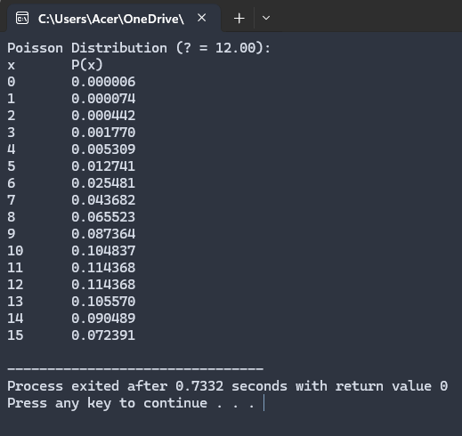
}
Output:

Lab 3:
- Write a program to estimate the value of PI using Monte Carlo Simulation.
Source code:
#include <stdio.h>
#include <stdlib.h>
#include <time.h>
double estimate_pi(int num_points) {
int points_inside_circle = 0;
srand(time(NULL));

// Generate random points
for (int i = 0; i < num_points; i++) {
double x = (double)rand() / RAND_MAX * 2 - 1;
double y = (double)rand() / RAND_MAX * 2 - 1;

if (x * x + y * y <= 1) {
points_inside_circle++;
}
}
return 4.0 * points_inside_circle / num_points;
}

int main() {
int num_points;

printf("Enter the number of random points for the simulation: ");
scanf("%d", &num_points);

double pi = estimate_pi(num_points);

printf("Estimated value of Pi: %lf\n", pi);

return 0;
}

Output:
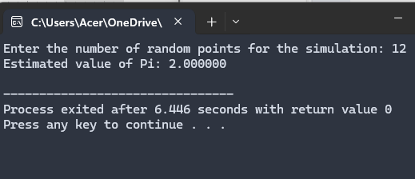

- Write a program to estimate the area under the curve using the Monte Carlo Simulation.
Source code:
#include <stdio.h>
#include <stdlib.h>
#include <time.h>
#include <math.h>

// Function representing the curve f(x) = x^2 (you can change this to any function)
double f(double x) {
return x * x; // Example: f(x) = x^2
}

// Function to estimate the area under the curve using Monte Carlo simulation
double estimate_area(double a, double b, int num_points) {
int points_under_curve = 0;

double max_y = f(b);

srand(time(NULL));
for (int i = 0; i < num_points; i++) {
// Random x value between a and b
double x = a + (b - a) * ((double)rand() / RAND_MAX);

// Random y value between 0 and max_y
double y = (double)rand() / RAND_MAX * max_y;

if (y <= f(x)) {
points_under_curve++;
}
}
double area = (b - a) * max_y * ((double)points_under_curve / num_points);
return area;
}

int main() {
double a, b;
int num_points;
printf("Enter the interval [a, b] to estimate the area under the curve: ");
scanf("%lf %lf", &a, &b);
printf("Enter the number of random points: ");
scanf("%d", &num_points);
double area = estimate_area(a, b, num_points);
printf("Estimated area under the curve: %lf\n", area);

return 0;
}
Output:
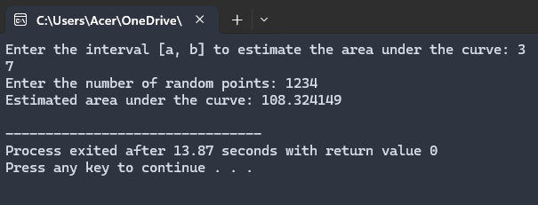

Lab 4:
- Customers arrive in a bank according to a Poisson's process with mean inter arrival time of 10 minutes. Customers spend an average of 5 minutes on the single available counter, and leave. Write a program in C to find:
a. Probability that a customer will not have to wait at the counter.
b. Expected number of customers in the bank.
c. Time a customer expects to spend in the bank.
Source code:
#include <stdio.h>

int main() {
double lambda = 1.0 / 10.0;
double mu = 1.0 / 5.0;
double rho = lambda / mu;
double P0 = 1 - rho;
double L = rho / (1 - rho);
double W = 1 / (mu - lambda);
printf("Probability that a customer will not have to wait: %.2f\n", P0);
printf("Expected number of customers in the bank: %.2f\n", L);
printf("Time a customer expects to spend in the bank: %.2f minutes\n", W);

return 0;
}
Output:

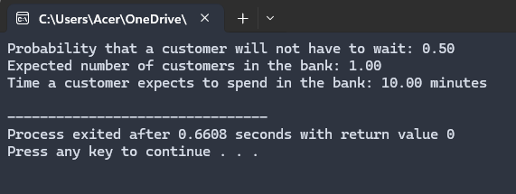

- At the ticket counter of football stadium, people come in queue and purchase tickets. Arrival rate of customers is 1/min. It takes at the average 20 seconds to purchase the ticket. WAP in C to calculate total time spent by a sports fan to be seated in his seat, if it takes 1.5 minutes to reach the correct seat after purchasing the ticket.
If a fan comes exactly before 2 minutes before the game starts, can sports fan expect to be seated for the kick-off?
Source code:
#include <stdio.h>

int main() {
int arrival_rate = 1;
int ticket_purchase_time = 20;
float seat_time = 1.5;

float ticket_purchase_time_in_minutes = (float)ticket_purchase_time / 60;
float total_time = ticket_purchase_time_in_minutes + seat_time;
printf("Total time spent by the fan: %.2f minutes\n", total_time);
float time_before_kickoff = 2.0;
if (total_time <= time_before_kickoff) {
printf("The fan will be seated in time for the kick-off.\n");
} else {
printf("The fan will not be seated in time for the kick-off.\n");
}

return 0;
}

Output:
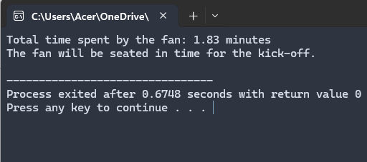

- Write a program to calculate measures of a M/M/1 Queue for a given value of Arrival Rate and Service Rate.
Source code:
#include <stdio.h>

int main() {
float lambda, mu;
float rho, L, Lq, W, Wq;

printf("Enter the Arrival Rate (lambda): ");
scanf("%f", &lambda);

printf("Enter the Service Rate (mu): ");
scanf("%f", &mu);

if (mu <= lambda) {
printf("The system is unstable! Service rate must be greater than arrival rate.\n");
return 0;
}

rho = lambda / mu;
L = lambda / (mu - lambda);
Lq = (lambda * lambda) / (mu * (mu - lambda));
W = 1 / (mu - lambda);
Wq = lambda / (mu * (mu - lambda));

printf("\nM/M/1 Queue Performance Measures:\n");
printf("Traffic Intensity (rho): %.4f\n", rho);
printf("Average number of customers in the system (L): %.4f\n", L);
printf("Average number of customers in the queue (Lq): %.4f\n", Lq);
printf("Average time a customer spends in the system (W): %.4f\n", W);
printf("Average time a customer spends in the queue (Wq): %.4f\n", Wq);

return 0;
}

Output:

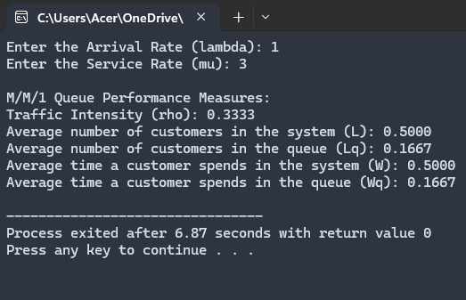

Lab 5:
- WAP to solve the below Weather problem
Rainy today => 40% Rainy tomorrow
=> 60% not Rainy tomorrow
Not rainy today => 20% Rainy tomorrow
=> 80% not Rainy tomorrow
What will be probability if today is not raining then not rain the day after tomorrow?
Source code:
#include <stdio.h>

int main() {
float P_rainy_tom_not_rainy_today = 0.20;
float P_not_rainy_tom_not_rainy_today = 0.80;

float P_not_rainy_day_after_tom_rainy_tom = 0.60;
float P_not_rainy_day_after_tom_not_rainy_tom = 0.80;
float P_not_rainy_day_after_tom;
P_not_rainy_day_after_tom =
(P_rainy_tom_not_rainy_today * P_not_rainy_day_after_tom_rainy_tom) +
(P_not_rainy_tom_not_rainy_today *
P_not_rainy_day_after_tom_not_rainy_tom);

printf("P(not rainy day after tomorrow | not rainy today): %.4f\n",
P_not_rainy_day_after_tom);
return 0;
}

Output:
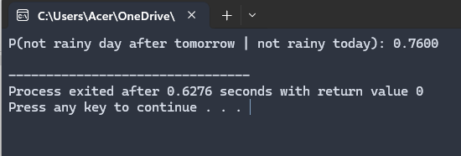

- WAP to solve the below problem.
Coke - Pepsi
Coke => 90% Coke
Pepsi => 20% Coke
Given a person is currently a Pepsi purchaser. What is the probability of purchase of coke after two purchases from now?
WAP to solve the above problem.
Source code:
#include <stdio.h>

int main() {
float P_pepsi_to_coke = 0.20;
float P_pepsi_to_pepsi = 0.80;
float P_coke_to_coke = 0.90;
float P_coke_to_pepsi = 0.10;

float probability_coke_after_two_purchases;

probability_coke_after_two_purchases =
(P_pepsi_to_coke * P_coke_to_coke) +
(P_pepsi_to_pepsi * P_pepsi_to_coke);

printf("Probability of purchasing Coke after two purchases, given current Pepsi
purchase: %.4f\n", probability_coke_after_two_purchases);

return 0;
}
Output:
